Risk | Status since P1 | Likelihood / impact | Mitigation and owner
Review Bombing & Spam | Unresolved | Low | Implement rate limiting, captcha for review submissions, and automated keyword flagging to quarantine suspicious reviews before publication.
Traffic Spikes on Release Days | Unresolved | Low | Design the architecture for horizontal scaling and cache static game information/average ratings to reduce database load during peak times.
Moderator Bottlenecks | Resolved | Low | Build efficient bulk-moderation tools, prioritize flagged content, and implement a tiered trust system where veteran reviewers bypass manual approval.
Reviewer Abandonment | Resolved | Very Low | Conduct usability testing on the submission form early in development to ensure rating options and text fields are straightforward for non-technical writers.
Moderation Scope Creep | In progress | Medium | Strictly limit the initial moderation tools to basic approve, reject, and flag functions, explicitly defining what is excluded from the current scope.
External Vendor Server Crash | Unresolved | High | Temporarily halt new reviews for games in the affected server

ID | Question | Raised by | Owner and due date | Status or answer | Assumption meanwhile
Q | How would a new gaming vendor enter the system | Ethan Nguyen | Ethan Nguyen, 11/8/2026 | They would apply to the system and after review they would be admitted or denied | They would just enter after signing into the system
Q | How would a vendor leave the system | Ethan Nguyen | Ethan Nguyen, 11/8/2026 | They would apply to the system and after acknowledging the request they can leave the system | They would simply leave the system whenever they wanted to

ADR-01 Layered (3-Tier)
Status | Accepted
Date and owner | 11/8/2026, Ethan Nguyen
Context (drivers) | QAS-3
Options considered | Different server architectures
Decision | Implemented
Consequences | Requires maintaining clear interfaces and multiple layers
Evidence | Spike 1, uses a 3-tier architecture (client, server, database(
Related | ADR-02

5.2 Object interaction models
Copy the block below for at least two of the use cases in 4.1; preferably including your riskiest.
5.2.x UC-xx [Use case name]
(a) Non-trivial steps. List the steps from 4.2 that need objects inside the system and say in one line why each of the others is trivial.
- Step 2 (Non-trivial): Requires system objects to parse search criteria, apply active genre and platform filters, query the catalog domain records, and rank matching candidates.
- Step 3 (Non-trivial): Requires the system to construct the structured search result set, calculate relative match scores, and format game summary entries for display.
- (Step 0 is the passive pre-state; Step 1 is the physical entry of search criteria by the actor; Step 4 is the actor selecting a title from the returned list).

(b) Scenario table.
Step |  |  |  | Subject (who acts) | Subject action (what it does) | Other data / objects (what is used) | Object acted upon (who receives)
2.1 | Gamer | submits search keywords and filter criteria | SearchQuery parameters | SearchController
2.2 | SearchController | creates query evaluation instance | text, genreFilter, platformFilter | SearchQuery
2.3 | SearchController | queries catalog records matching title criteria | SearchQuery.text | Game
2.4 | SearchController | filters matching titles by selected platform | SearchQuery.platformFilter | Platform
2.5 |  |  |  | SearchController | filters matching titles by selected genre | SearchQuery.genreFilter | Genre
3.1 |  |  |  | SearchController | creates ranked search result list | matching Game instances | SearchResult
3.2 |  |  |  | SearchResult | retrieves summary details and aggregate score | title, aggregateScore | Game
3.3 |  |  |  | SearchController | presents ranked matching game list | collection of SearchResult items | Gamer
(c) Analysis sequence diagram.
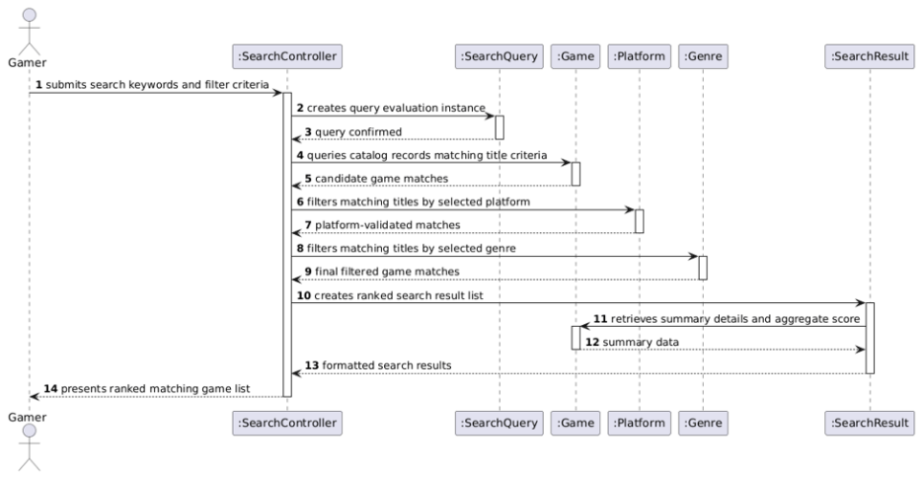
Figure 5.2.x Analysis sequence diagram for UC-xx; message numbers match the scenario table

